Student Name: Weight: 15%
Student ID: Marks: /120

Assignment: Stack-Based Calculator for Postfix Notation with Binary Search Trees
Introduction
The goal of this assignment is to implement a text-based calculator that can evaluate arithmetic expressions in postfix notation using a stack data structure and handle variables using a binary search tree (BST). You will design and implement an array-based stack, and then develop and implement a provided algorithm to evaluate postfix expressions, handle integer operands and basic arithmetic operations, integrate a binary search tree to store variables and their values, visually display the binary search tree, and handle deletion of all variables. The correctness of your implementation can be verified by following the provided postfix expressions as test cases in the sample runs.
Instructions
- Before you start:
- Review the class materials for Modules 3, 4 and 5.
- Complete the case exercises provided in these modules.
- This is a team assignment. Work in groups of three students.
- This assignment should take about six hours and you’re expected to complete it outside of scheduled hours.
- Follow the Program Guidelines below to ensure your program meets the specifications.
- Ensure your program meets the requirements in the Restrictions section.
- Use the Tips and Tricks sections in Modules 3, 4, and 5 for guidance.
- Rigorously test your solution, as outlined in the Testing section.
- In addition to writing the code, you are required to present your code to the instructor. Refer to the Code Presentation for further details.
- Refer to the Marking Criteria section for details on how you will be assessed.
- Individually, complete a Peer Assessment for your team. Review the Peer Assessment section below.
- Follow the Submission Guidelines section and submit your completed assignment according to the date and time stated by your instructor to the Assignment submission area in Brightspace.

Program Guidelines
Create a Java program that fulfills the following requirements:
- Implement the provided ADT stack interface using an array-based implementation. The stack interface should support operations such as push, pop, peek, isEmpty, etc.
- Implement a BST to store variables and their values. The binary search tree should support operations such as insert, search, delete, deleteAll and display.
- Implement a method named evaluatePostfixExpression(String expression) that takes a string representing a postfix arithmetic expression and returns an integer (the result of the evaluation).
- The calculator should handle integer operands and should support the following operations: addition (+), subtraction (-), multiplication (*) and division (/).
  - Each operand and operator in the expression should be separated by spaces. For example, the postfix expression 2 3 + represents the infix expression 2 + 3.
- Evaluation algorithm:
  - If an operand is encountered, push it onto the stack. If a variable is encountered, search for its value in the binary search tree and push the value onto the stack.
  - If an operator is encountered, pop the top two operands from the stack. Perform the operation using the operator and operands. Push the result back onto the stack.
  - If an operand or variable is encountered, store it in the binary search tree with its value using the insert operation.
- Repeat these steps until the expression is fully evaluated.
- The result will be the top element on the stack.

Restrictions
- Must organize your code solution into appropriate packages to promote a modular and structured approach.
Your Java program should meet the following restrictions:
- Do not use any built-in Java utilities or libraries that directly evaluate postfix expressions.
- Implement the stack data structure, binary search tree, and postfix evaluation algorithm from scratch.
- Adhere to good coding practices, including:
  - Proper code indentation
  - Meaningful variable names
  - Appropriate inline and multiple comments to explain the code’s functionality
- Handle any possible errors or exceptions that may occur during the execution of the program.

Tips and Tricks
- Before starting the implementation, make sure you understand the concept of postfix notation, how the evaluation algorithm works and how binary search trees operate.
- Practice by solving a few postfix expressions manually to familiarize yourself with the process.
- Use a resizable/dynamic array to implement the stack data structure, allowing the stack to grow as needed.
- Implement helper functions such as push(), pop(), peek(), isEmpty(), etc., to manage the stack operations.
- Use suitable data structures and variables to store operands, operators and intermediate results during the evaluation process.
- Implement the binary search tree operations (insert, search, delete, deleteAll, display) to manage variables and their values.
- Make sure the evaluatePostfixExpression method can handle variables. If a token is an operand, check if it is a variable by searching for its key in the BST. If the variable is found, push its corresponding value onto the stack. Otherwise, handle it as an integer operand and then push it onto the stack.

Code Presentation
In addition to developing your code, you will have the opportunity to showcase your understanding of the assignment, the implementation details, and your problem-solving approach. Your presentation should be clear, concise, and structured to effectively communicate your assignment’s key aspects. Consider the following:
- Problem Explanation: articulate the problem your code is addressing.
- Challenges: describe any challenges or constraints your team encountered.
- High-Level Architecture: present the high-level architecture of your project. Discuss the major components and modules within your code.
- Code Structure and Organization: walk through the structure and organization of your code. Highlight key classes, functions, and data structures.

Peer Assessment
Each team member must complete a peer assessment of their group members and submit it with the same title as the “Your Name_AssignmentName/ProjectName”. The purpose of this peer review is to offer constructive feedback to your peers. Please utilize the template provided below to assign ratings to each of your group members on a scale of 1 to 3, where:
- 1 = Significant area for improvement
- 2 = Acceptable but with some areas for improvement
- 3 = Excellent contribution
 | <Name 1> | <Name 2> | <Name 3> | <Name 4>
Motivation and engagement in assignment | /3 | /3 | /3 | /3
Timely submission of deliverables | /3 | /3 | /3 | /3
Effective communication and problem solving | /3 | /3 | /3 | /3
Other comments for your peers

BST Implementation
Tree Node: Since each node in the BST tree should contain two fields (a key field to store the variable name and a value field to store the variable’s value), a class representing a node in the BST tree should have fields for the key and value, as well as references to the left and right child nodes.
Pseudocode:
class Node:
String key
int value
Node left
Node right

BST Operations
Insertion: Implement an insertion method that takes the variable name (key) and its value as input and inserts a new node with the given key-value pair into the BST tree. Ensure that the tree maintains the BST property, i.e., all keys in the left subtree are less than the current node's key, and all keys in the right subtree are greater than the current node's key.
Searching: Implement a search method that takes a key as input and returns the value associated with that key if found in the BST tree. Perform a binary search starting from the root node and traversing left or right based on the key comparison.
Pseudocode:
function search(key):
current = root
while current is not null:
if key equals current.key:
return current.value
else if key < current.key:
current = current.left
else:
current = current.right
// Handle key not found case
Deletion: Implement a deletion method that takes a key as input and removes the node with the given key from the BST tree. Handle different cases, such as deleting a node with no children, deleting a node with one child and deleting a node with two children. Ensure that the tree remains a valid binary search tree after deletion.
Deletion of All Nodes: Implement a method named deleteAll() that deletes all nodes from the BST tree.
Displaying: Implement a method named displayTree() that displays the binary search tree in a hierarchical structure. This will help visualize the arrangement of nodes in the tree. You may use a recursive approach, StringBuilder and a loop to achieve this.
Postfix Calculator Implementation
Create a class named PostfixCalculator that includes the following components:
- An instance variable named variableTree of type BinarySearchTree to store variables and their values.
- An instance variable named stack of type StackInterface<Integer> to implement the stack for the postfix evaluation.
Constructor: Implement a constructor for the PostfixCalculator class that initializes the variableTree and stack.
Method: evaluatePostfixExpression(String expression):
Implement a method named evaluatePostfixExpression(String expression) that takes a string representing a postfix arithmetic expression and returns the result of the evaluation as an integer. This method should implement the steps described earlier to evaluate the expression using a stack and handle variables using the binary search tree.
Method: setVariable(String key, int value):
Implement a method named setVariable(String key, int value) that sets a variable with its corresponding value in the binary search tree.
Method: deleteAllVariables():
Implement a method named deleteAllVariables() that deletes all variables from the binary search tree.
Additional Methods: Implement any additional helper methods required for the proper functioning of the postfix calculator.

Testing
- Test your Java program with various eight postfix expressions listed in the following sample runs, including expressions with variables.
- Use the setVariable method to set the variables and return the postfix expressions in the main method before starting to evaluate those expressions.
- After evaluating each expression, delete all variables using the deleteAll method and visually display the binary search tree using the displayTree method.

Sample Runs
When your program begins, it should display a JOptionPane displaying the purpose of the program and prompt asking you to press OK to initiate the program!
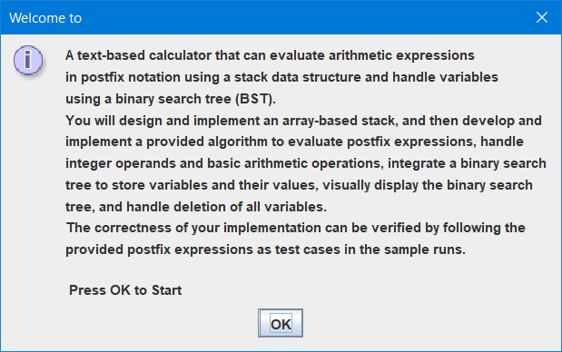
After pressing 'OK,' your program should commence displaying the postfix expression, its binary tree, result, and a message confirming the deletion of variables.
Note the test cases in the following postfix expressions from 1 to 8 should be sited in your main method.

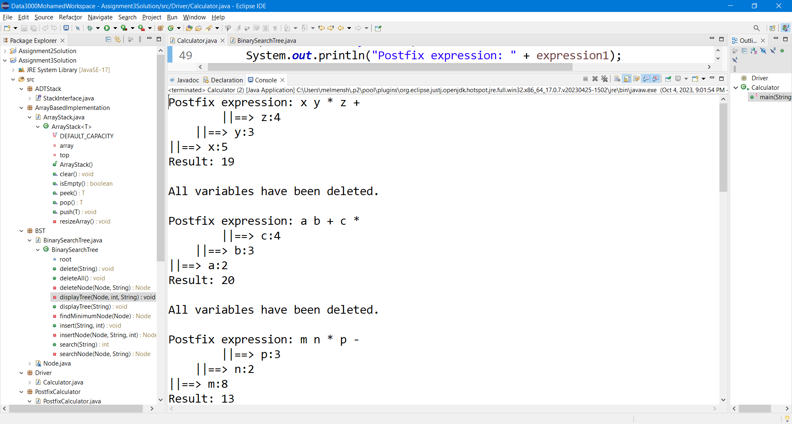
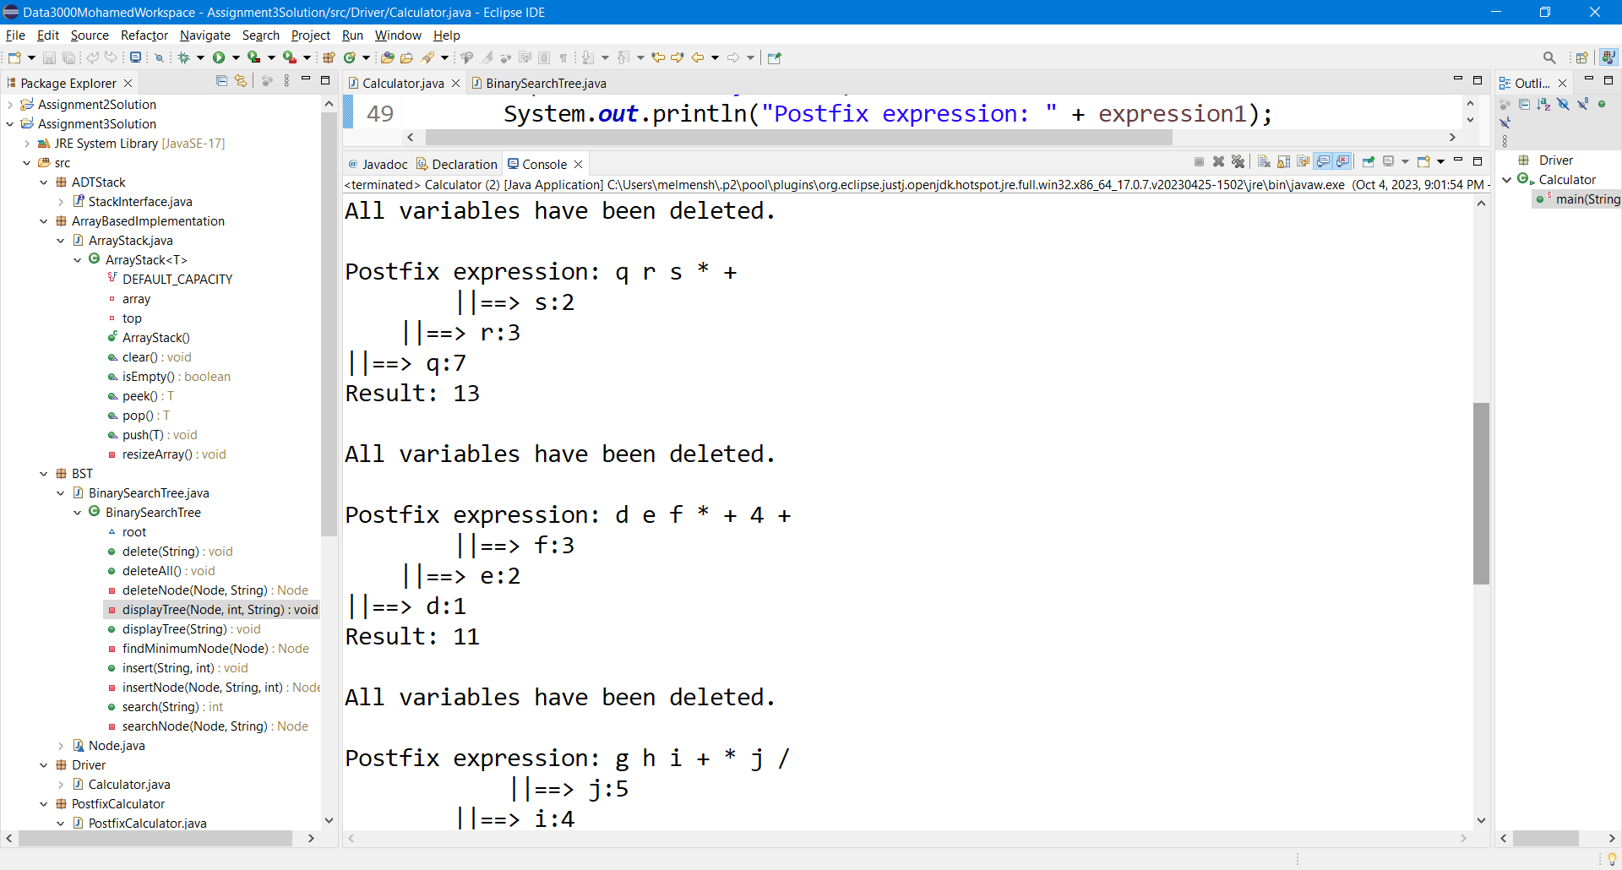
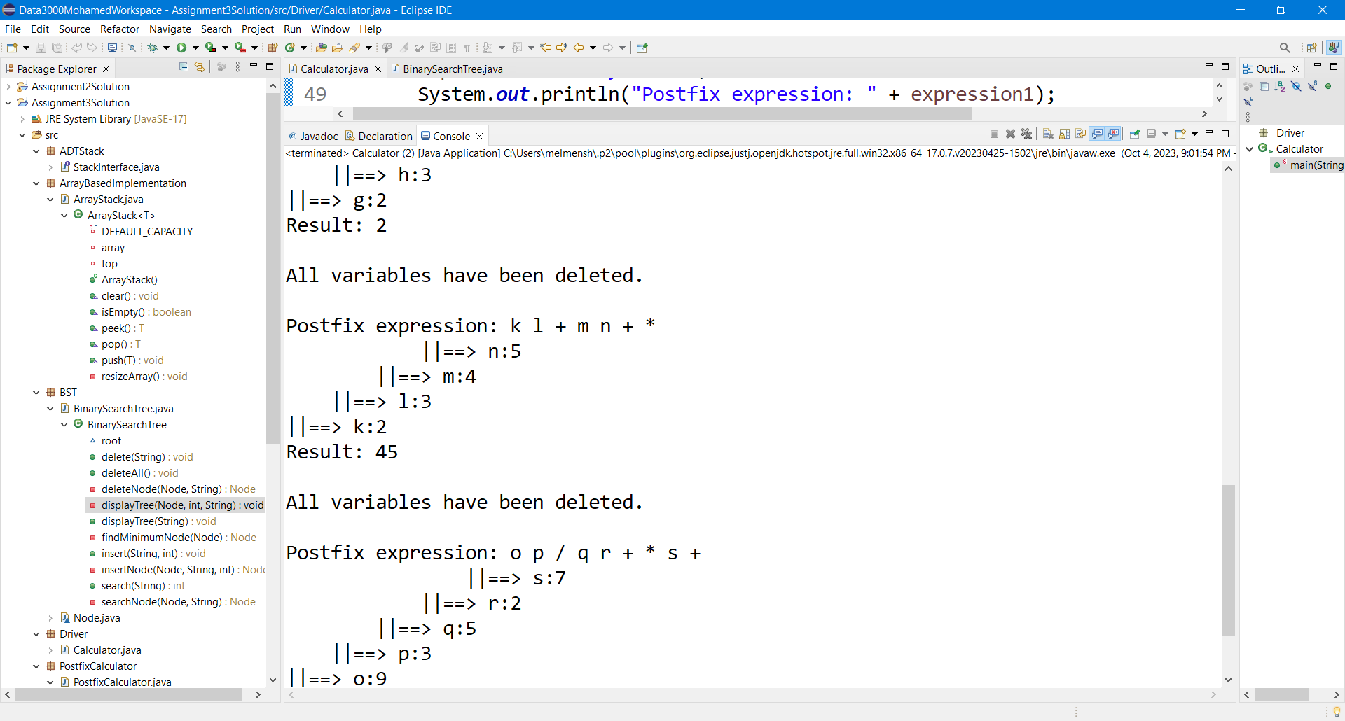
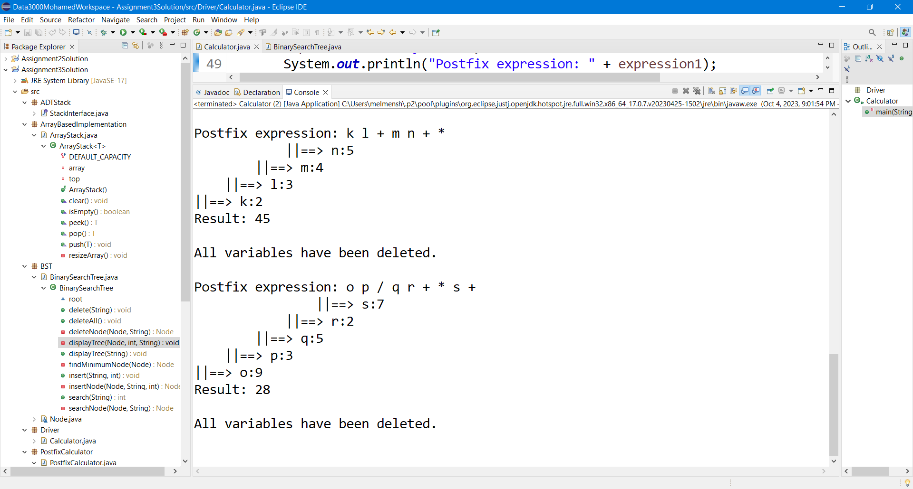
//Postfix expression 1
setVariable("x", 5);
setVariable("y", 3);
setVariable("z", 4);
//Postfix expression 2
setVariable("a", 2);
setVariable("b", 3);
setVariable("c", 4);
//Postfix expression 3
setVariable("m", 8);
setVariable("n", 2);
setVariable("p", 3);
//Postfix expression 4
setVariable("q", 7);
setVariable("r", 3);
setVariable("s", 2);
//Postfix expression 5
setVariable("d", 1);
setVariable("e", 2);
setVariable("f", 3);
//Postfix expression 6
setVariable("g", 2);
setVariable("h", 3);
setVariable("i", 4);
setVariable("j", 5);
//Postfix expression 7
setVariable("k", 2);
setVariable("l", 3);
setVariable("m", 4);
setVariable("n", 5);
//Postfix expression 8
setVariable("o", 9);
setVariable("p", 3);
setVariable("q", 5);
setVariable("r", 2);
setVariable("s", 7);

Here is the step-by-step explanation of the BST visualization:
- The postfix expression being evaluated is g h i + * j /.
- The BST is constructed based on the variables used in the expression and their respective values.
- The root node of the BST is the node labeled j with a value of 5. It is represented as ||==> j:5.
- The left child of the root node is the node labeled i with a value of 4. It is represented as ||==> i:4.
- The left child of the i node is the node labeled h with a value of 3. It is represented as ||==> h:3.
- The left child of the h node is the node labeled g with a value of 2. It is represented as ||==> g:2.
- Since there are no further left children, the right subtree of the g node is displayed as empty.
- The remaining part of the tree is displayed in a similar manner.
- The right child of the i node is the rightmost node labeled j with a value of 5. It is represented as ||==> j:5.
- Since there are no further right children, the left subtree of the j node is displayed as empty.
The resulting value of the postfix expression g h i + * j / is 2, which is displayed as Result: 2.

Submission Guidelines
To ensure an organized submission process, please follow these instructions carefully:
- Generate a JAR file: Begin by compiling your Java program and creating a JAR file. This JAR file should contain all the necessary compiled classes and resources essential for running your program effectively.
- Create a ZIP archive: Assemble all the required files into a single ZIP archive. This archive should consist of the following items:
  - JAR file: Place the generated JAR file, containing your Java program, inside the ZIP archive. Ensure that the JAR file includes all the dependencies and resources required for the program to execute correctly.
  - Readme file: Include a small readme file within the ZIP archive. This file should provide clear instructions on how to run your program successfully.
- Organize the ZIP archive: Arrange the files inside the ZIP archive in a well-structured manner. Consider creating separate directories or folders for organization and clarity.

Student Code of Conduct
Academic dishonesty is considered to be an extremely serious academic offense. Reference Procedure AC. 3.4.1 – Student Code of Conduct (available on http://www.sait.ca).
Be prepared to share an explanation of your solutions. Your instructor may select any team to provide an explanation to any question.

Marking Criteria
Criteria | Needs Improvement | Good | Excellent | Marks
Implementation of ADT Stack (Array-Based) | Incorrect or incomplete implementation of stack operations. (5 marks) | Correct implementation of essential stack operations (push, pop, peek, isEmpty).  Adequate handling of stack size and resizing. (10 marks) | Precise implementation of stack operations with optimal efficiency.  Effective management of stack size and resizing. (15 marks) | /15
Implementation of BST | Incorrect or incomplete implementation of BST operations. (7 marks) | Accurate implementation of BST operations (insert, search, delete, deleteAll, display).  Proper maintenance of binary search tree property. (14 marks) | Flawless implementation of BST operations with exceptional precision.  Robust maintenance of binary search tree property. (20 marks) | /20
Postfix Expression Evaluation Algorithm | Inaccurate handling of operands, operators, and variables. (10 marks) | Proper handling of operands, operators, and variables in expressions.  Accurate evaluation of postfix expressions using stack and BST.  Adequate variable lookup and operand handling. (20 marks) | Flawless handling of operands, operators, and variables.  Precise evaluation of postfix expressions using stack and BST.  Optimal variable lookup and operand handling. (30 marks) | /30
Code Quality and Style | Disregard for coding practices, inconsistent indentation. (7 marks) | Adherence to coding practices: proper indentation, meaningful variable names, and comments.  Well-structured code with clear use of helper methods.  Handling of exceptions and errors. (14 marks) | Exemplary coding practices: consistent indentation, descriptive variable names, and detailed comments.  Highly organized code with optimized use of helper methods.  Exceptional error handling and robustness. (20 marks) | /20
Test Cases and Sample Runs | Incomplete or limited testing. (5 marks) | Thorough testing of various postfix expressions, including those with variables.  Correct display of binary search tree in sample runs.  Accurate evaluation results and variable deletion handling. (10 marks) | Comprehensive testing, including extensive coverage of edge cases.  Precise display of binary search tree in sample runs.  Perfectly accurate evaluation results and variable deletion handling. (15 marks) | /15
Code Presentation | Limited or unclear explanation of the problem, challenges, and project architecture. (6 marks) | Provides a clear explanation of the problem, challenges, and project architecture. (12 marks) | Presents a compelling and engaging overview, covering all aspects effectively. (17 marks) | /17
Total |  |  |  | /117

Final Individual Marks
Team Total (up to 117) | x | Peer Evaluation Multiplier (as a percentage) | = | Total
 | x |  | =
 |  |  |  | +
Peer Evaluations Completed (3)
 |  |  |  | =
Final Individual Marks |  |  |  | /120

